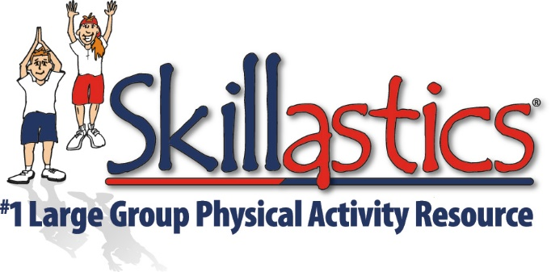

Skillastics®: Supporting the Quality California Standards for Expanded Learning

Our Core Focus:
To create positive physically active experiences for students of all ages and abilities.

We Create These Experiences by:
Providing After School Physical Activity Leaders with the tools and resources that equip students with the appropriate knowledge, skills, behaviors, and confidence to be physically active for a lifetime.

Safe and Supportive Environment –

Skillastics® allows all students, regardless of their physical ability, to enjoy being physically active in a non-competitive, non-threatening environment that highlights individual strengths.

- Every student has the opportunity to be a leader.

- 100% engagement allows instructors the freedom to access every student’s participation and progression.

- Skillastics® is aligned with the 5 Social and Emotional Core Competencies: Self-Awareness, Self-Management, Social Awareness, Relationship Skills, & Responsible Decision-Making.

Active and Engaged Learning –

Skillastics® allow participants to enhance their leadership and cooperative skills in a physically active environment. Participants are placed in 6 teams, where each team works together in order to allow advancement on to the next activity.

- The Skillastics® Physical Activity Program promotes thought-provoking discussion guided by the Skillastics® Physical Activity Program Lesson Plan Guide. Each day begins with an activity associated with a Character Trait, which is the highlighted Character Trait of the day. Talking points in the Lesson Plan Guide encourage stimulating conversations around the Character Trait of the day.

- Skillastics® seamlessly integrates STEM and Nutritional Learning with physical activity. This allows students the opportunity to improve their health and well-being while simultaneously increasing STEM and Nutritional knowledge.

Skill Building –

The Skillastics® Physical Activity Plan is designed to incrementally enhance fitness levels and develop sport skills in a fun, non-threatening environment for all ages and abilities. The sequencing activities outlined in the Skillastics® Physical Activity Guide allow students to build on previously learned skills.

- Skillastics® Activity Kits provide three levels of repetitions along with versatile options. These allow staff to clearly develop and define learning goals for participants throughout each Skillastics® lesson.

- Skillastics® allows a progression of learning by first focusing on the Character Trait of the day. The progression continues by allowing participants to engage in lessons that develop understanding of the skills and activities, which are then reinforced by experiencing the Skillastics® technique.

- Skillastics® is a team-building activity where participants learn to effectively read, comprehend and communicate activities that the whole team must engage in together prior to advancing. This cooperation and collaboration of everyone on the team reinforces and helps develop these critical skills required as adults.

Youth Voice and Leadership –

Skillastics® is as creative as the instructor who is using it. Instructors can provide participants the freedom to create their own options while experiencing Skillastics®. Their creativity is inspiring and lends to increased self-esteem and self-efficacy.

Healthy Choices and Behaviors –

When students participate in a consistently positive physically active environment, that experience will help develop optimistic perceptions of healthy behaviors into adulthood.

In addition, Skillastics® is fun. Instructors understand all the underlying positive effects it has on social emotional learning, self-esteem and skill-building. Participants have a positive experience being physically active, and don’t realize the impact it has on him/her on so many levels.

- Skillastics® is an evidence and researched-based program.

- Skillastics® Activity Kits lessons are age and developmentally appropriate.

- The Skillastics® Activity Kit Lesson Plan Guide is a daily, step-by-step curriculum that is simple to execute. Instructors quickly gain knowledge and skills while following every lesson.

- Skillastics® versatility allows staff engagement, as well as a perfect resource to promote healthy behaviors during a family coordinated event.
Diversity, Access and Equity –

Skillastics® is an all-inclusive program for all ages and abilities. The diverse academically integrated questions and activities engage students of all cultures, backgrounds and abilities. Not every child is an athletic. However, every child deserves to have a positive experience being physically active in an environment that highlights individual strengths.

Clear Vision, Mission and Purpose –

The Skillastics® Physical Activity Program is simple to follow and is easily transferrable to new instructors. The Skillastics® technique is super easy to set up and execute. One key advantage is once the students learn the Skillastics® method, they apply that same method to all Skillastics® themed activities. This eliminates instruction time and allows for more active movement time for the participants.

Collaborative Partnerships –

Skillastics® will allow up to 100 participants to be active at the same time. It’s ability to engage so many individuals at one time is a perfect resource for family or community events.

Continuous Quality Improvement –

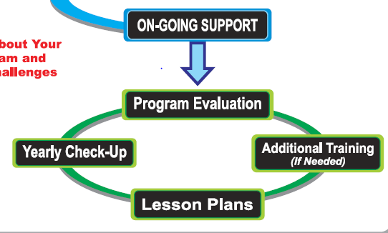
When an Expanded Learning Program invests in a Skillastics® Physical Activity program, there will be clear communication regarding consistent follow up. We guarantee that our Skillastics® Specialists will be there to answer any questions or to help you through any challenges that may arise.
Program Management –

Skillastics® will maintain well-defined channels of communication with staff to assure the Skillastics® Physical Activity Program is running smoothly. The Expanded Learning Program Coordinators will be confident in knowing the staff is operating the physical activity component of their program effectively and efficiently.

Sustainability –

On-going support, evaluations, options for additional lesson plans and participants ability to take home My Daily Physical Activity Workout ensure sustainability of the Skillastics® Physical Activity Program.

