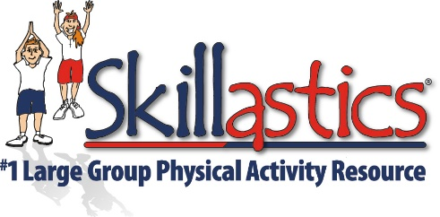

Skillastics Alignment with the Core Social and Emotional Learning Competencies

SELF-AWARENESS
The ability to accurately recognize one’s own emotions, thoughts, and values and how they influence behavior. The ability to accurately assess one’s strengths and limitations, with a well-grounded sense of confidence, optimism and a mindset of growth.
- Identifying emotions
- Healthy self-perception
- Recognizing strengths
- Self-confidence
- Self-efficacy

Skillastics® is a resource of team activities. The success of Skillastics® is dependent on each participants behavior. Personal and social responsibility is crucial. How one interprets and expresses information about an activity, how one encourages his/her teammates, and how one demonstrates his/her level of involvement, all factor into recognizing and assessing individual emotional involvement. Skillastics® allows children of all ages and skill levels equal chance of participating and working on a level playing field. Skillastics® allows each participant to lead and succeed, raising the level of self-confidence and self-efficacy.

SELF-MANAGEMENT
The ability to successfully regulate one’s emotions, thoughts, and behaviors in different situations – effectively managing stress, controlling impulses, and motivating oneself. The ability to set and work toward personal and academic goals.
- Impulse control
- Stress management
- Self-discipline
- Self-motivation
- Goal-setting
- Organizational skills

Skillastics® is self-directed and provides instructors the freedom to assess participants individually or within a small group setting. Skillastics® creates a positive environment that invites both, participant self-reflection and self-evaluation, which enhances personal and social responsibility. Skillastics® offers both a competitive and non-competitive option. The competitive option challenges participants to play at a higher intensity (MVPA) while encouraging teamwork, fair play and responsibility.

SOCIAL AWARENESS
The ability to take the perspective of, and empathize with others, from diverse ethnicities and cultures. The ability to understand social and ethical norms for behavior and to recognize family, school, and community resources and supports.
- Differentiated
- Empathy
- Appreciation for diversity
- Respect for others

Skillastics® is an all-inclusive activity for all ages and abilities. Children are grouped into 6 teams of varied abilities and cultures. For teams to advance, each team member takes a turn being the leader. Skillastics® offers diverse, academically integrated questions and activities to engage individual cultures, ages and abilities. Skillastics® diversity depends on individual strengths and differences to create a strong and successful team.

RELATIONSHIP SKILLS
The ability to establish and maintain healthy and rewarding relationships with diverse individuals and groups. The ability to communicate clearly, listen well, cooperate with others, resist inappropriate social pressure, negotiate conflict constructively, and seek and offer help when needed.
- Communication
- Social engagement
- Relationship-building
- Teamwork

Skillastics® is a team activity. Skillastics' teams work collectively to complete the desired repetitions required under the direction of a team leader. Each team member participates in the role of the leader. As a team mate, effective communication, active engagement, listening and comprehension skills are required to advance around the mat. Positive relationships are built as each team succeeds.

RESPONSIBLE DECISION-MAKING
The ability to make constructive choices about personal behavior and social interactions based on ethical standards, safety concerns, and social norms. The realistic evaluation of consequences of various actions, and the consideration of one's self and others well-being.
- Identifying problems
- Analyzing situations
- Solving problems
- Evaluating
- Reflecting
- Ethical responsibility

Skillastics® rules are simple and easy to follow, Skillastics® rules are paramount to the success of the activity. Overall performance is enhanced when Skillastics® rules are followed. Skillastics® provides its instructors with behavior modification differentiation. Skillastics® provides opportunities for large group management behavior redirection allowing more time on task. Skillastics® provides a positive cooperative learning environment that integrates academics from STEM, nutrition, fitness, problem solving, and more.

