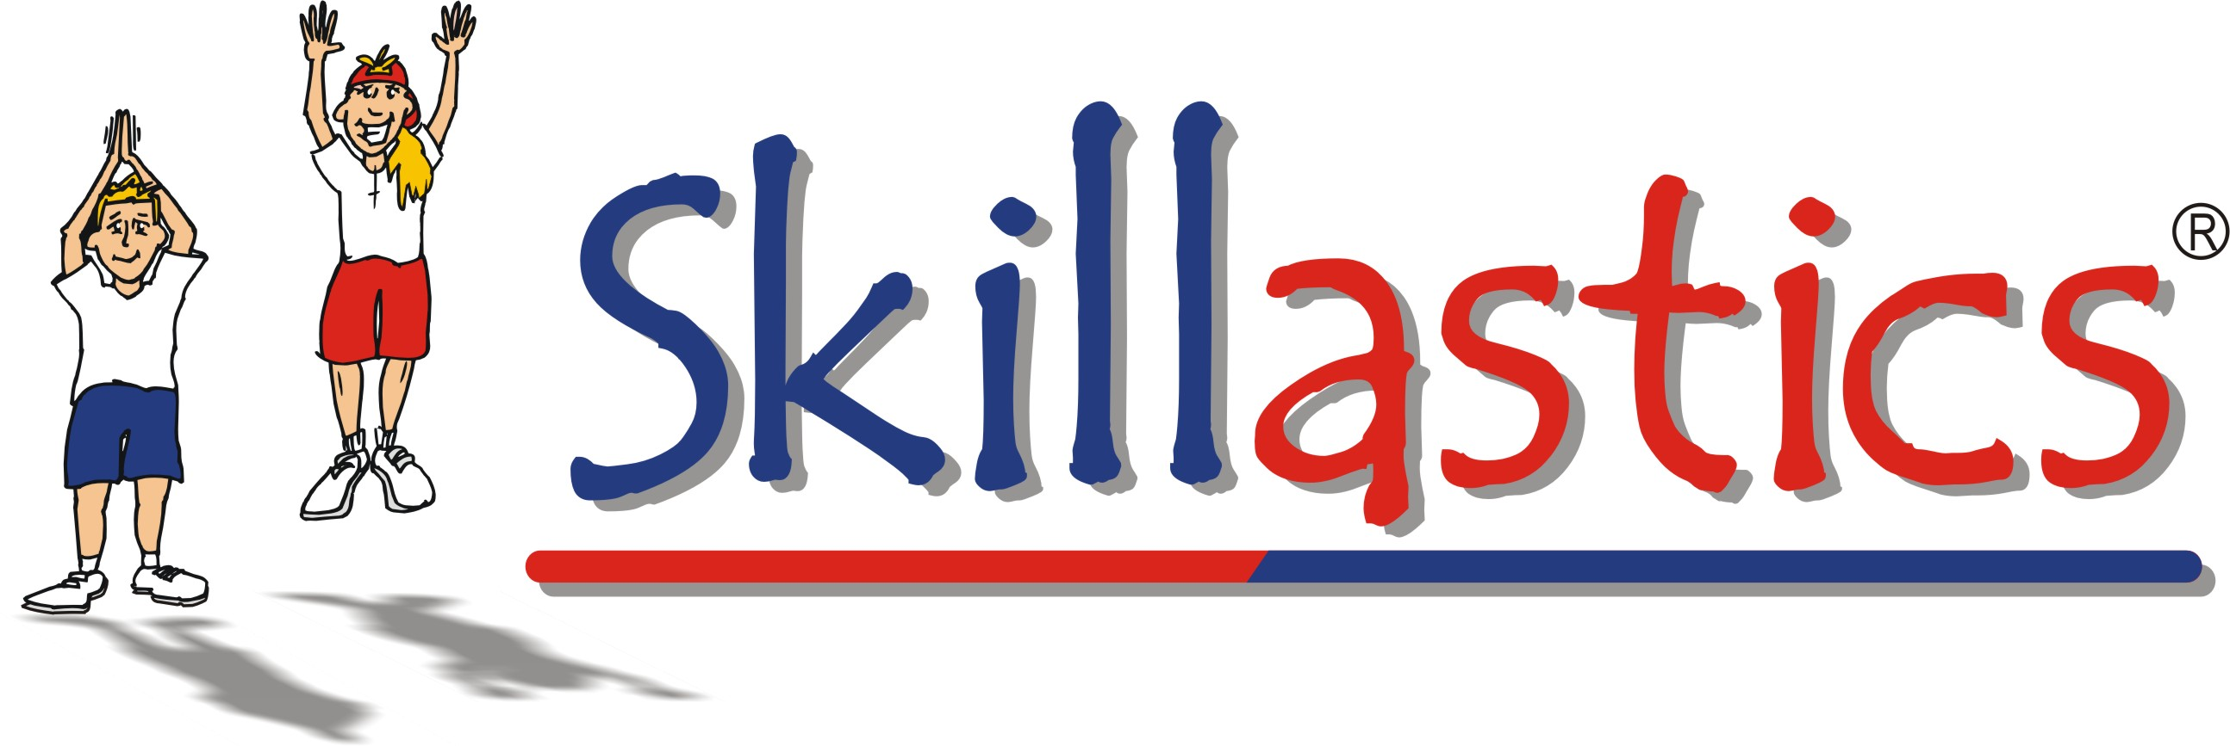

Grant Narrative for Skillastics® Research Based Practices

__________________________ District will incorporate several research-based strategies, including Skillastics®. Skillastics® is a series of physical activity kits integrated with nutritional and academic components including STEM principals. It will be incorporated into the physical education curriculum in order to both enhance our current physical education program and increase physical activity and academic integration by incorporating Skillastics® Activity Kits that create a balance of learning.

The Skillastics® program is designed to enhance Physical Education Curriculum through developing children's social skills (State Standard ?), improving motor skill development (State Standard ?), and increasing physical activity (State Standard ? ). Social skills (State Standard ?) are developed through the introduction of teamwork, problem solving and conflict resolutions strategies such as (cooperation, taking turns, sharing, communicating and negotiating with classmates). Motor skill development activities include (locomotor skills, throwing and catching, dribbling with hands and feet, volley, and striking, are accessible for special need children and typical children. Children's physical activity (State Standard ?) overall average heart rate during 20 minutes of Skillastics® play was 142 bpm, putting students comfortably in the energy efficient zone. This zone provides cardiovascular benefits for students and allows them to be active for a long period of time. (Walters, et al. 2009). Click Here for Skillastics alignment with the National Physical Education Standards.

There are five components to the program:
- Developmentally appropriate activities
- Consistent set of rules and expectations
- Opportunities to develop teamwork and cooperation
- Integrating academic principals like STEM, Math, and Reading
- Assessment opportunities and tracking progress with the combination of heart rate monitors and or pedometers.

Skillastics® is intended to maximize the number of students involved in physical activity (Absolute Priority) rather than students waiting in line for their turn or just standing around. The Physical Activity Guidelines for Children recommended by the CDC suggests that children and adolescents should do 60 minutes (1 hour) or more of physical activity each day. Healthy People Goals 2020 for the nation suggests implementing programs that increase the length of, or activity levels in moderate to vigorous physical activity (MVPA) in school-based physical education class over 50% of the time (Absolute Priority). Skillastics® adds to the minutes that children are active and receiving practice time for motor skill development by adding 26 activities for each of the 13 activity kits, adding up to over 300 fitness and skill developmental activities. The instructional manuals, instructional DVD's and task cards identify the motor skill each activity develops for focused instruction from the teacher.

Skillastics® research indicated that physical activity increased significantly as a result of implementing the Skillastics® program, especially among less active students.

A key component of Skillastics® is promoting and maintaining physical activity outside of Physical Education class itself. Instructors can include many of the individual activities from the Skillastics® Activity Kits on fitness calendars, and as suggestions for fitness or activity logs to promote physical activity outside of physical education class. The activities can also be used for classroom teachers to provide activity breaks during the school day. The series of Skillastics® Activity Kits provide all children maximum opportunities to participate and practice skills when they are played during physical education class, afterschool, or even in the classroom. By connecting what is done in the physical education class or other teaching environments, and what students can do outside of the class, Skillastics® is a great tool to promote a physically active lifestyle.

Combining developmentally appropriate physical education, before and after school physical activity opportunities and classroom fitness breaks fulfills the well documented need for increased physical activity. By providing an environment where children can be physically active in a non-competitive, non-threatening atmosphere, children are more apt to reach the CDC's Guideline of 30-60 minutes a day of moderate to vigorous physical activity. In return, this fulfills the Absolute Priority of 150 minutes (elementary) and 225 minute (secondary) per week as required by the Secretary as reporting measures for this grant (GEPA). State physical education standards call for students to achieve high levels of physical activity, learn skills of conflict resolution and problem solving, and finally to increase students' motor skill development. ALL of these standards are met with the implementation of the Skillastics® program and are reinforced and enhanced in after school programs and by providing students increased opportunities to be physically active throughout the school day.

Skillastics® offers on-site professional development training and on-going support.

Budget Summary – Skillastics Activity Kit Options:
Option 1: Everything You Ever Wanted Package , includes:
Basketball Skillastics®, Soccer Skillastics®, Volleyball Skillastics®, Tennis Skillastics®, BFit4 Winter, Fitness Skillastics®, Fitness Xtreme Skillastics®, Character is Cool Skillastics®, Let's Move In School Skillastics®, STEM Skillastics®, Halfpint Skillastics® (English or English/Spanish version), Skillastics® Elementary and Secondary Nutritional Cards, Skillastics® Poly Spots, Teaching Basketball Fundamentals DVD, Teaching Shooting DVD, Sandy Spin Slade: Beyond Basketball Documentary, Off the Rim Book, 24 multi-colored basketballs, 24 multi-colored soccer balls, 24 multi-colored volleyballs, 24 Junior Tennis Racquets, and 144, Quick Start 36′ Foam Tennis Balls.
Price: $4,372.56

Option 2: Skillastics® Game Package, includes:
Basketball Skillastics®, Soccer Skillastics®, Volleyball Skillastics®, Tennis Skillastics®, Fitness Skillastics®, Fitness Xtreme Skillastics®, BFit4 Winter Skillastics®, Character is Cool Skillastics®, STEM Skillastics® Let's Move in School Skillastics®, Halfpint Skillastics®(English or English/Spanish version), Skillastics® Nutritional Cards, and Skillastics® Poly Spots.
Price: $2,557.78
Option 3: Individual Skillastics® Product Breakdown Costs
- Basketball Skillastics® -$224.95
- Soccer Skillastics® -$224.95
- Volleyball Skillastics® -$224.95
- Tennis Skillastics® -$224.95
- Fitness Skillastics® -$224.95
- Fitness Xtreme Skillastics® -$224.95
- STEM Skillastics® - $299.95
- Character is Cool Skillastics® – $294.95
- Let's Move in School Skillastics® - $299.95
- Be Fit 2 Learn Skillastics® Math - $179.96 (Includes one set of grade math cards)
- Be Fit 2 Learn Skillastics® Math - $239.90 (Includes two sets of grade math cards)
- Be Fit 2 Learn Skillastics® Math - $299.85 (Includes three sets of grade math cards)
- Be Fit 2 Learn Skillastics® Math - $359.80 (Includes four sets of grade math cards)
- Be Fit 2 Learn Skillastics® Math - $419.75 (Includes 5 sets of grade math cards)
- BFit4 Winter Skillastics® – $224.95
- Halfpint Skillastics® (3-5 year olds) -$109.95
- Halfpint Bilingual Skillastics® (English/Spanish) -$109.95
- Fitness FunZone® - $2,999.95
- Fitness FunZone® Trail - $1,499.95
- Teaching Basketball Fundamentals DVD (Download) -$24.95
- Teaching Basketball Shooting Fundamentals (Download) -$24.95
- Sandy Spin Slade: Beyond Basketball Documentary DVD -$29.95
- Skillastics® Nutritional Cards – Elementary $59.95
- Skillastics® Nutritional Cards – Secondary $59.95
- Sets of Skillastics® Poly Spots -$24.95

Skillastics® Professional Development Training:
- Half day – $900 (3 hours – with Skillastics Educational Specialist Trainer) plus expenses (TBD)
- Half day – 1,100 (3 hours – with Sandy Spin Slade Trainer), plus expenses (TBD)
- Full day – $1,500 (5-6 hours – with Skillastics Educational Specialist Trainer), plus expenses (TBD)
- Full day - $2,200 (5-5 hours – with Sandy Spin Slade Trainer), plus expenses (TBD)
*Expenses include roundtrip airfare, hotel accommodations, rental car (if applicable), and meals. Average cost: $500-$1,000.

